Dairy Farmers in Maharashtra Dump Milk Produce, the Government Offers Subsidy
July 22, 2020

https://www.grainmart.in/news/dairy-farmers-in-maharashtra-dump-milk-produce-the-government-offers-subsidy/

The on-going pandemic adversely impacted dairy farmers due to the lowering of the procurement prices. Thus, the depressed Maharashtra dairy farmers resorted to dumping milk on roads and stopping supply to urban areas as a sign of protest.
Dairy Farmers in Deep Distress
Since April, the prices paid to farmers for milk production has steadily decreased due to the pandemic lockdown. Accordingly, in Maharashtra, the prices came down from Rs. 30 per litre for milk with 3.5 % fat and 8.5 % SNF (solid non-fat) to just Rs. 17- 22.50 per litre. Further, farmers have no choice but to sell at a fixed price as milk is a perishable commodity. Over 50% decline in milk price would have an adverse effect on their livelihood. Thus, the dairy crisis has become a political dispute in the state.
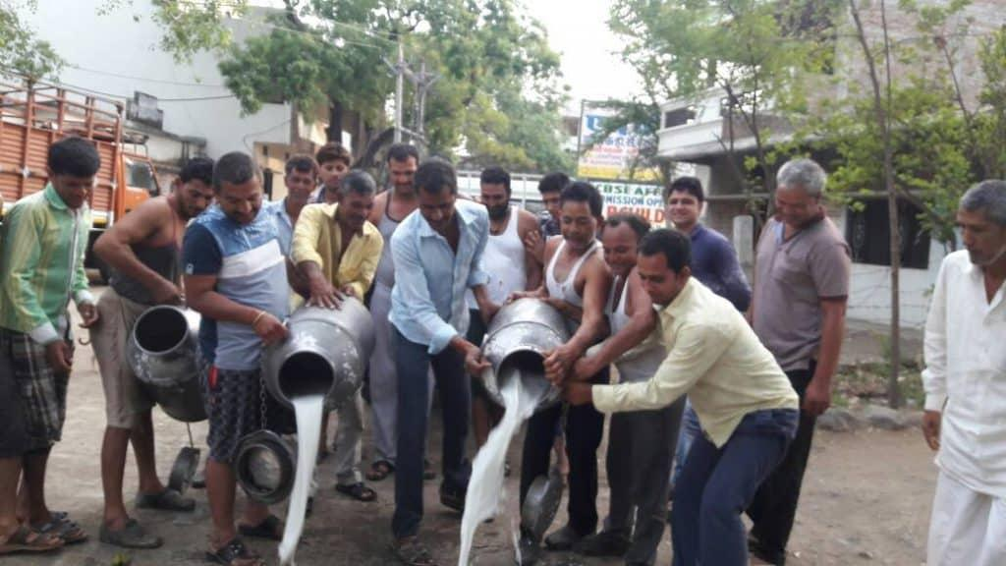Dairy Farmers in Maharashtra Dump Milk as a sign of Protest
Farmers Seeking Higher Procurement Prices
Demanding higher procurement price and subsidies, Swabhimani Shetkari Sanghatana (SSS) started a “milk agitation”. Consequently, a meeting was held between the members of SSS and AIKS (All-India Kisan Sabha) along with the state dairy development minister, Mr Sunil Kedar. Unfortunately, the meeting did not yield favourable results. Further, the opposition in the state has also demanded Rs. 10 increase in the procurement prices. Failing to do this, they warned that they would go on a strike from 1st August.
On the other hand, Mr Kedar has assured that the problem will be sorted soon and that the interest of all the parties would be taken care of.
Subsidy for Dairy Farmers
The Maharashtra government has offered a subsidy of Rs. 5 per lire to the struggling farmers. Following this, the SSS called off the one day strike. Despite cancelling the protest, they put forth more demands.
The State President, Mr Sandip Jagatap Kavi, urged the centre to halt the import of 10,000 tonnes of skimmed milk and create an SMP buffer stock of 30,000 tonnes. Further, he called for an export subsidy of Rs. 50 for shipments outside India. Also, he warned that officials would face severe charges if the demands are not met in due time.
Dairy stocks- a Safe Bet?
Dairy stocks have seen a positive gain during the lockdown. In fact, they have seen a V-shaped recovery and now are in a steady consolidation phase. Accordingly, Parag Milk Foods has seen a jump of 87% in the last four months, and Heritage Foods has jumped up by 84%. Thereby, estimates suggest that dairy stocks will perform well despite the reduction of sales and demand from the consumers as well as the hospitality sector.
Further, Rs. 15,000 crore stimulus package to the livestock sector with an interest subvention of 3% has helped.
In all, the dairy farmers plight must be understood and dealt within the country. Farmers have been suggesting subsidies similar to the Rs 5 per litre subsidy for a long time that must be considered. It is essential that the government actively takes part in improving their livelihood.

Commentary

The coronavirus pandemic has led to lowering of milk prices as a result of lower demand due to closing down of restaurants, hotels and sweets shops.
Because of this, the dairy farmers of Maharashtra have started dumping milk on roads and stopping supply to urban areas as a way of protesting.

The price of milk has kept falling since April from Rs.30 per litre to Rs. 17-22 now. Until now, farmers have sold their milk at this price due to its perishable nature which prevents it from being stored for later. The diagram below shows the fall in price of milk after lockdown-

Price of milk
S1

D1
Rs 30

D2
Rs 20

Q1
Q2

Quantity of milk

Fig 1. Impact of lockdown on the milk market

The reason for the demand for milk being perfectly elastic is because the milk market is at perfect competition. The original price of milk before lockdown was Rs.30 and the demand was Q1 units. Due to the lockdown, the demand curve shifted to the left from D1 to D2, causing the equilibrium price to fall to around Rs.20 and the equilibrium quantity to drop to Q2 units. This has resulted in a sharp decline in the revenue earned by dairy farmers and adversely affected their livelihood. Their revenue fell from Rs.(30xQ1) to Rs.(20xQ2).

So, there was a need for government intervention. In response to this, the government provided the farmers a subsidy of Rs.5 per litre to increase their revenue. The effect of this can be seen in Fig 2.

S1
+ Rs. 10 procurement price
Quantity of milk
Price of milk

S2= S1-subsidy
Rs 35
Rs 30
D1
Rs 25

D2
Rs 20

Q4
Q1
Q3
Q2

Fig 2. Impact of a Rs.5 subsidy and a Rs.10 increase in procurement prices

As a result of the subsidy, the supply curve will shift to the right and reach S2. Due to this, the farmers’ revenue will increase to Rs.(25xQ3). However, this is still lower than their initial revenue. So, they were still unhappy.
Hence, Dairy farmers also demanded a Rs.10 increase in procurement price. The procurement price is the price at which the government buys commodities for maintaining a buffer stock.

Fig. 2 also shows the possible effect of increasing the procurement price of milk from Rs.25 to Rs.35.
The government would buy Q4 at Rs.35 per unit. This situation would be very beneficial for producers of milk because their revenue would now increase to Rs.(35xQ4) which is a lot higher than their revenue with the subsidy and even higher than their initial revenue. This would increase employment as more workers would have to be hired to produce higher output.
However, this would be very expensive for the government to do because they would not only have to buy a lot of milk but also have to create storage facilities which would further increase costs. It may also be difficult for the government to find a country willing to buy the large quantity of milk at a price above Rs. 35. This could be the reason why the demand for increase in procurement price was declined. The declining of this policy by the government was one of the causes that led to the milk agitation.
Another disadvantage of this policy is that local consumers would now find it very expensive to buy milk, so they might have to rely on cheaper imported milk unless the government sells some of it locally at a price under Rs.35 per unit.

Later in the article, it is mentioned that an export subsidy of Rs.50 per litre is being considered. This may be a good alternative solution to increase the willingness of dairy producers to produce milk and to increase exports. By doing this, the government would also lose a lot of revenue, but the cost might be less than the cost of storing and transporting the milk themselves. If so, the export subsidy might be a good solution.
However, the downside to doing this is that it will discourage producers from selling locally as they could make higher profits by exporting to other countries. If the Rs.50 export subsidy is approved, the revenue of milk producers would increase a lot but the supply of milk in Maharashtra would be likely to be very scarce.

To conclude, the Rs. 5 subsidy given to dairy producers will not be enough to increase their revenue to what they used to be. Increasing the procurement price of milk or providing a larger subsidy for exporting it may be a better solution for the government to take up.

