BANK OF ENGLAND

Bank of England keeps policy unchanged and follows Fed with dovish tone
PUBLISHED THU, MAR 18 20218:01 AM EDTUPDATED THU, MAR 18 202112:53 PM EDT
Elliot Smith@ELLIOTSMITHCNBC
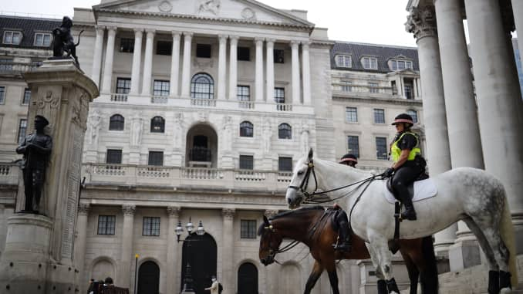
Mounted police officers sit in outside the Royal Exchange and the Bank of England in London on June 17, 2020.
TOLGA AKMEN | AFP via Getty Images
The Bank of England held interest rates steady on Thursday and mirrored the dovish tone set by the U.S. Federal Reserve on the prospect of future tightening of monetary policy.
The central bank’s Monetary Policy Committee voted unanimously to keep its main lending rate at 0.1% and maintain its target stock of asset purchases at £895 billion ($1.2 trillion).
It comes as bond yields around the world have moved higher on expectations of rising inflation, and the possibility that central banks could tighten monetary policy sooner than expected. On Wednesday, however, U.S. Federal Reserve Chair Jerome Powell said the Fed does not intend to hike interest rates through 2023, and the Bank of England struck a similar tone Thursday.
“The Committee does not intend to tighten monetary policy at least until there is clear evidence that significant progress is being made in eliminating spare capacity and achieving the 2% inflation target sustainably,” it said.
The MPC expects annual inflation to return to around 2% in the spring, reflecting the recent rise in energy prices and take earlier falls in oil prices out of the equation.
“These developments should have few direct implications for inflation over the medium term, however. Inflation expectations remain well anchored,” the MPC added.
The BOE has cut rates twice since the onset of the pandemic from 0.75%, and deployed an unprecedented quantitative easing program, as it looks to steer the British economy toward recovery.
There had been growing speculation about a rate cut into negative territory. Last month, the BOE said British lenders would need at least six months to prepare for a negative interest rate environment, but stressed that it was not planning to deploy such a measure imminently. However, recent developments now have markets assessing when to expect a hike.
Since the last meeting of the MPC, official figures confirmed that the U.K. economy suffered its largest annual contraction for more than 300 years in 2020. However, initial estimates showed GDP contracting by less than expected in January despite the country remaining in lockdown.
In its Budget earlier this month, the British government promised an expansion of its fiscal support to £407 billion in the short term, but mapped out a gradual unwinding of measures and tightening of the public purse.
The U.K. has also made significant progress on its rollout of Covid-19 vaccinations, with more than 24 million people having received at least one shot.

No bond yield pushback
“The Bank of England is clearly following in the Federal Reserve’s footsteps with regard to tightening or tapering off monetary support,” said Paul Craig, portfolio manager at Quilter Investors.
He added that the outlook for reopening was still too uncertain and the vaccine rollout will be front and center for the Bank, which will maintain the status quo for now, likely resulting in a “tolerated overshoot” for inflation.
However, Aberdeen Standard Investments Senior Economist Luke Bartholomew noted that the Bank has not used its latest policy announcement as an opportunity to “join its colleagues at the European Central Bank in trying to push back against the recent increase in global bond yields.”
“Instead, the Bank seems relatively comfortable with the idea that the market moves reflect an improving growth and inflation outlook rather than an adverse and undesirable tightening in financial conditions,” Bartholomew said in an email Thursday.
“Indeed the Bank hinted that its current short term growth forecasts will need revising higher in light of the relative strength of the January GDP report and the planned lockdown easing path.”

Macroeconomics Commentary: -

This article talks about post-Brexit, mid-pandemic state of UK economy, with the enactment of an expansionary monetary stimulus, where more money is injected into the economy and interest rates were reduced (twice from 0.75%), fearing the “largest annual contraction” of UK economy in 300-years. Now, the Bank’s Monetary Policy Committee (MPC), has decided to keep the policy unchanged, however, depending on the outturn of economic events, the interest rates could ether increase or decrease in future.
The Bank of England (BoE) is UK’s monetary authority, which performs functions of managing money supply, issuing currency, and controlling interest rates in UK. These major macroeconomic tasks are carried out by implementing monetary policy, that is manipulation of money supply in an economy by controlling its general level of interest rates. Mid-pandemic, feared by a deep recessionary period, BoE issued an expansionary monetary stimulus, by reducing interest rates and injecting more money into the economy, as can be seen in Fig.-A.
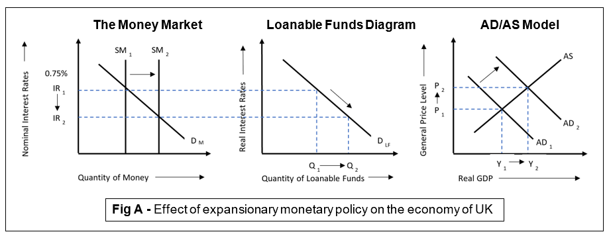
Here, injection into the economy through quantitative easing, increased money supply, which is indicated by the rightward shift of Money Supply (SM) curve from SM₁ to SM₂, making the interest rates (IR), fall from IR₁ to IR₂. This fall in interest rates takes effect in the market of loanable funds, where it increased quantity demanded of loanable funds(Q₁→Q₂). Consequently, making firms and households more willing and able to take loans from commercial banks for investment and consumption purposes at a lower interest rates, since availability of credit increased and borrowing costs decreased, hence boosting confidence within firms and households. This is depicted from the rightward shift of aggregate demand (AD) curve in AD/AS model from AD₁ to AD₂, that increased real gross domestic product (GDP) (Y₁→Y₂), and general price level (P₁→P₂).
Now, due to “recent rise in energy prices” and with MPC’s expectations of rising inflation around spring to 2%, BoE must decide whether keeping policy unchanged by maintaining interest rates is the most suitable option for the economy.
In this situation, BoE could raise interest rates when inflation rate approaches towards the target rate of 2%, and implement contractionary monetary policy, whose effect on UK’s economy in Fig.-B. Here, the SM curve shifts leftwards(SM₁→SM₂), raising interest rates (IR₁→IR₂), because money is comparatively deficient. This upsurge in interest rates will directly affect loanable funds market, contracting quantity demanded of loanable funds(Q₁→Q₂). And since higher rates obstructs borrowing as, therefore investment and consumption of firms and households would decrease, respectively. Eventually, leading AD to shift leftward(AD₁→AD₂), hence, decreasing real GDP and increasing demand deficient unemployment, while reducing inflationary gap.
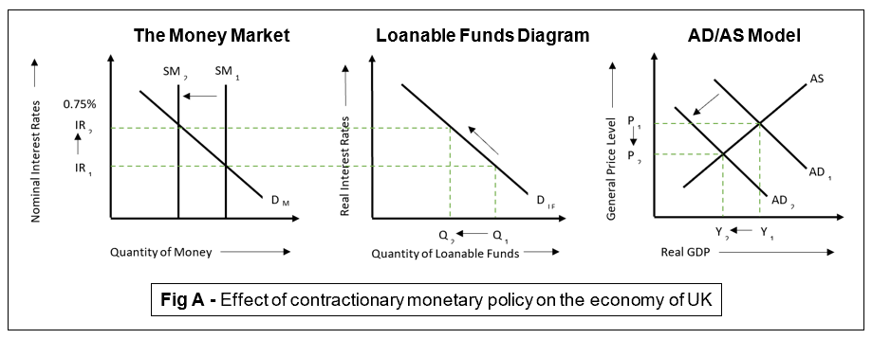
From the two diagrams, it is evident that implementation of monetary policy creates a conflict in BoE’s macroeconomic objectives because the effect of expansionary monetary policy enacted is merely calculated contradictory predictions which certainly hinders the path of UK’s policymakers in setting clear macroeconomic goals and designing effective policies.
The current implementation of expansionary monetary policy by maintaining interest rates almost zero, is certainly capable of reducing unemployment and increasing economic growth. But it also negatively impacts the economy by possibly opening an inflationary gap(mainly demand pull). This also lowers exchange rates as a result, making imports costlier which in turn decreases trade deficit of the UK economy.
In addition to this, a limitation of monetary policy is its ineffectiveness in tackling cost push inflations, which will be the case that will be materialised due to Sterling depreciation in UK economy. And implementation of expansionary monetary policy within an economy suffering from cost push inflation would lead to an inflationary spiral, that has its own negative impacts upon the economy including a fall in living standards and slower economic growth.
In order to stabilize the UK economy, one possible solution would be if the government and BoE execute a fiscal policy incorporated with monetary policy because even with the crowding-out effect and time-lag issue of the fiscal policy, it has a lasting effect over the whole economy unlike monetary policy, which is more suitable in achieving short-term success. Acknowledging the conflicting predictions about the UK economy, implementing two policies together would act as a safety net for the economy which is capable of reducing any possible issue, in case the economy changes unpredictably for worse. And in order to ensure budgetary room for a policy like this to be implemented, the UK government could cut budget deficit, i.e. where revenue is exceeded by government expenditure.

Word Count = 731

