Liquor Taxes Could Go Up 400%, Thanks to Congressional Dysfunction
A temporary cut in federal taxes on alcohol fueled the growth of American distilleries, but its expiration threatens their demise.
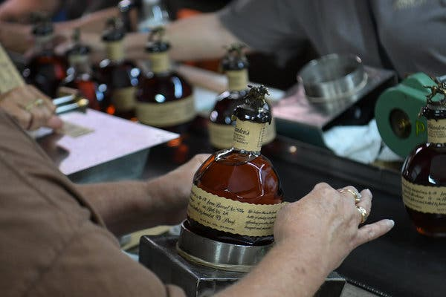

Bottles of bourbon for shipment at the Buffalo Trace Distillery in Kentucky.Credit...Bryan Woolston/Reuters

By Clay Risen
- Dec. 16, 2019

On Tuesday, lawmakers moved closer to approving a one-year extension for the alcohol tax cut.
The last two years have been good ones for Lyon Distilling. At the small rum producer in St. Michaels, Md., a town on the Eastern Shore of Chesapeake Bay, production has jumped from 4,000 bottles a year to 40,000. Four employees have become 15.
Explosive consumer demand explains some of that growth, said Jaime Windon, the company’s chief executive and co-founder. But she attributes most of it to a steep cut in federal excise taxes on alcoholic beverages, which Congress passed at the end of 2017 as part of the Tax Cuts and Jobs Act.
“We used to be tiny,” she said. “Now we’re running like a machine.”
Thousands of small distilleries, breweries and wineries have similar stories. But their fortune may end soon, thanks to congressional paralysis: The tax cut, known as the Craft Beverage Modernization and Tax Reform Act, is set to expire on Dec. 31, and legislators have until Friday to extend it.
If they don’t, distilleries like Lyon will face a 400-percent tax increase, with the first payment for many due on Jan. 15. That has craft-beverage producers scrambling.
“The anxiety level with these small distilleries is high,” said Chris Swonger, the chief executive of the Distilled Spirits Council of the United States. Industry representatives expect that many small companies will have to lay off employees or close entirely, a turn that could undermine the country’s boom in craft brewing and distilling.
Particularly frustrating for these companies is the fact that the tax cut enjoys overwhelming bipartisan support — a House bill to make it permanent, introduced earlier this year, has 324 co-sponsors, while an identical Senate version has 73.
Such legislation would normally sail through Congress, most likely as part of a so-called extender package of similar targeted cuts. Instead, observers say, it has become a casualty of congressional dysfunction and partisan fighting over taxes and spending.
The tax cut, originally introduced in 2015, was supposed to be permanent, but was trimmed to two years as a compromise to get it into the 2017 tax bill. Industry lobbyists assumed that making it permanent would not be a problem — this summer, the House Ways and Means Committee passed legislation to do so, and a Senate task force endorsed the idea.
But those proposals soon got caught up in larger debates about tax reform, and Congress let the issue sit idle. In recent days, Congressional offices have told lobbyists they are rushing to reach a deal on tax reform, which they hope to attach to the year-end spending bill. But they can’t promise that an extension to the tax cut will be part of it.
“We’re all a little dizzy,” said Margie Lehrman, the chief executive of the American Craft Spirits Association, which lobbies on behalf of small distillers. “The congressional leadership seems stuck because of issues much larger than us.”
Industry lobbyists and legislators who support the bill say that at this point the most they can realistically expect is a one-year extension. But such short-term relief would make it hard for distillers to make long-term investments, like hiring staff, increasing production or buying new equipment.
“The hard part for us is the lack of certainty,” said Robert P. Koch, the president of the Wine Institute, which represents the wine industry in Washington. “To have it extended just one year makes it tough to plan.”
The 2017 legislation cut the amount that all distilleries had to pay on the first 100,000 proof gallons from $13.50 to $2.70 (a proof gallon is a gallon of spirit at 50 percent alcohol). Breweries and wineries received similar reductions, though in their cases the cuts were largely reserved for small producers. Such excise taxes are paid on top of normal corporate taxes.
Trade associations representing all three industries said the vast majority of their members used the tax savings to invest in new equipment and craft breweries added 15,000 jobs in 2018, the latest year on record, after an average of just 5,000 for the previous three years.
“I’ve got 7,500 main-street members using that money to reinvest in their companies and their communities,” he said.
The sharp reduction in taxes also encouraged hundreds of new businesses to open, including about 2,000 breweries and 400 distilleries in the last two years. Those companies are especially unprepared for a sudden increase in their excise taxes, which, for most distillers, must be paid every other week.
“There are distillers now who do not know what it’s like not to pay more than $2.70,” said Ms. Windon. “I don’t know how their business plans will accommodate that.”
Extending popular, but temporary, tax cuts has long been an end-of-the-year ritual on Capitol Hill. But many of the temporary cuts have since been made permanent, leaving a dwindling number of affected groups to scramble for support every few years. A number of provisions being considered alongside the alcoholic beverage excise tax have already lapsed, including a biodiesel tax credit, despite strong support from Iowa Republican Charles E. Grassley, the head of the Senate Finance Committee.
Despite its strong bipartisan support, the Craft Act has its critics, many of whom say it gives away too much to big producers. All distillers, no matter the size, get a break on their first 100,000 proof gallons. While most craft distillers make only a small fraction of that — Lyon Distilling produces about 5,000 proof gallons a year — many large distillers make 100,000 gallons or more a week.
Large brewing companies also benefit. AB InBev, which owns Budweiser, Corona and many other brands, now receives about $12 million in tax savings. But bringing big producers on board was a political necessity, said Mr. Pease. “From our perspective, if that’s what it takes, we’re fine with that,” he said.
Still, even skeptics are shocked at how a bill with such broad support — and a track record of boosting investment and job growth — could be scuttled because of political logjams.
“Who doesn’t like the idea of a craft brewer getting a break?” said Adam Looney, a tax expert at the Brookings Institution who has criticized some elements of the tax cut. “It’s an indictment of Congress’s ability to do the basic elements of its job.”

Microeconomics Commentary : -
This article talks about the potential issues that can arise in USA after discontinuance of ‘The tax cut.’ An ad valorem excise-tax [a fixed percentage of levy placed on certain products (goods and services)] might be reimplemented on liquor making it more expensive for customers to purchase and producers to supply. But there’s conflicting viewpoints about the tax reintroduction as liquor consumption is discouraged in society but ‘the tax cut’ boosted economy.
Trade associations and bipartisan supports the house bill of making the tax cut permanent as it generated high employment. But liquor consumption incurs negative consumption externalities which occurs when the consumed good/service inflicts harmful effects upon the third party. In this case, the negative effects are the deterioration of consumer’s health and its after effect on their families, therefore not only increasing crime rates but poverty too.
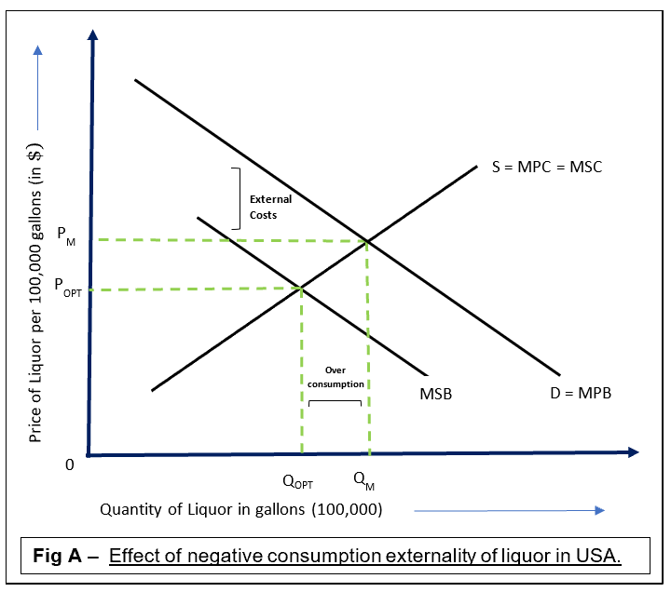
As can be seen in Fig.-A, consumers would consume at P_{M},Q_{M}, where MPB=MSC, in order to maximize their private benefits, and by ignoring the negative externality procreated. However, the social optimum equilibrium is at P_{OPT},Q_{OPT}, where MSB=MSC. Therefore, resulting in market failure due to over-consumption of liquor(Q_{M} -Q_{OPT}) which can be removed via government interventions like taxation.
Although intervention was needed, US congress reduced tax under the ‘Tax Reform Act’ instead of increasing it which caused congressional dysfunction.
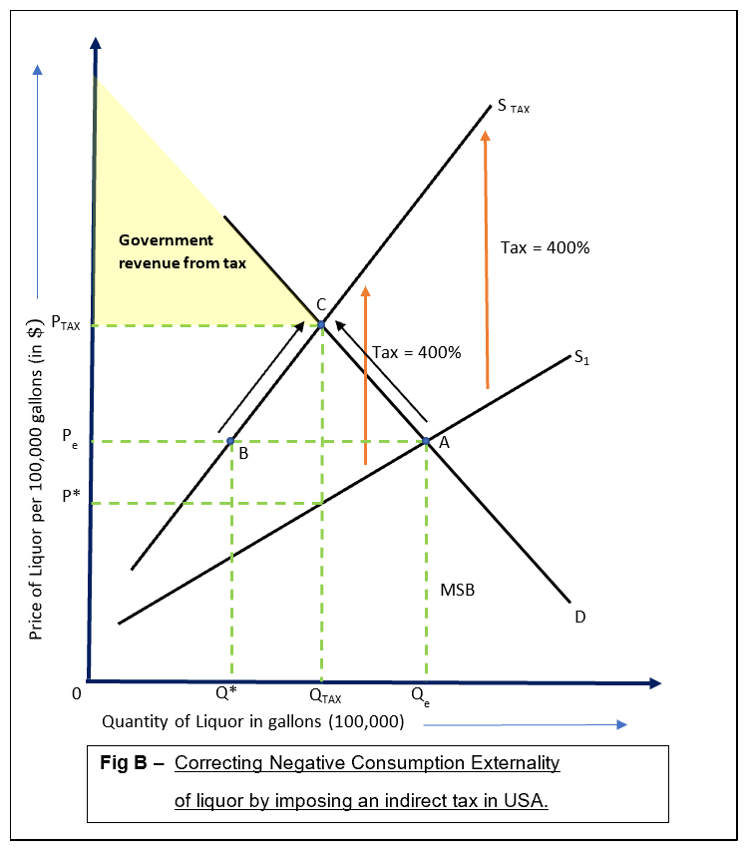
Fig.-B. depicts the effect of reimplementing tax in USA. Being an ad valorem tax (percentage-tax), the numeric-value of tax increases with the price, therefore S₁ diverges with S₂. The current equilibrium is P_{e}Q_{e}. However, after tax, producers would be willing and able to supply at Q* at the same price. Consequently, leading to excess demand against which market forces will contract along the demand curve(A→C) and extend along the supply curve(B→C), hence shifting to ‘Z’ with lower quantity(Q_{TAX} ) and higher price(P_{TAX}) than P_{e}Q_{e} which will create a situation where consumers and producers will have to spend more than the current situation to consume/supply the same quantity of liquor.
Consequently, consumers will be less willing and able to purchase liquor, which will decrease its quantity demanded hence reducing the incidence of health risks like kidney failures. A 400% tax can potentially reduce US consumption of liquor; hence taxation would be quite an effective solution. Additionally, it can significantly increase tax revenue for government, that can be further spent on to discourage liquor consumption by educating US citizens about harmful consequences of over-consumption of liquor.
Although this tax could ameliorate health of US liquor consumers, it might arise problems amidst the society because over-consumption of liquor is majorly a private cost to the consumer; it is consumer’s own will to consume it despite knowing its health related issues. Thus, regardless of the good intentions in reintroducing liquor taxes, the government is constraining the consumer’s freedom of choice – after all, it could be the consumer’s intentional disregard to the negative health consequences related with liquor-consumption. Hence, a liquor tax restricts consumer’s freedom too.
In addition to this, ‘about 2,000 breweries and 400 distilleries’ came into business after the tax cut, and reimplementing taxes ‘could undermine the country’s boom’ as it may make some of these firms to go out of business since they won’t be earning much profits as before because higher prices(P_{TAX} > P_{e}) will reduce quantity demanded of liquor (Fig.-B: Q_{e}→Q_{TAX}); thus, entrepreneurs may no longer be willing and able to produce and supply liquor products; forcing firms to shut down. This will negatively affect the US economy and is likely to increase unemployment rates.
Yet, instead of shutting production, few firms may continue production by treating the imposed liquor tax as incentive to cut the concentration of liquor added in their products; consequently evading the high tax. However, the quantity of liquor demanded might decrease even after its high inelastic demand, because consumers tend to be more willing in spending money on highly concentrated liquor beverages than lighter ones as it doesn’t taste the same. On the contrary, production costs would decrease since comparatively less concentration of liquor is incorporated. This could fill-up for the revenue loss caused by a lower quantity of liquor demanded, but only to a limited extent as liquor is relatively a cheap resource.
In conclusion, although a 400% liquor tax could benefit government’s tax revenue and health of US liquor consumers, it might evoke issues concerned with the firm’s production activities and consumer’s freedom of choice – could be one of the reasons for congressional dysfunction.

Word Count = 738

