Canada slaps retaliatory tariffs on US aluminium goods
- 7 August 2020
- Share
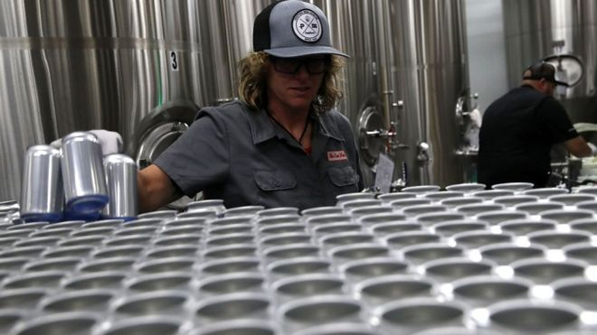
The US may reimpose tariffs on Canadian aluminium
https://www.bbc.com/news/world-us-canada-53683569
Canada has announced a C$3.6bn ($2.7bn, £2.1bn) tariff on US aluminium products a day after US President Donald Trump imposed a 10% tariff on some Canadian aluminium products.
Canada and the US reached a deal last year to lift tariffs on steel and aluminium imports that had been imposed on grounds of "national security".
Mr Trump reintroduced them on Thursday to protect the US industry.
Friday's retaliatory tariffs by Canada will go into effect on 16 September.
The countermeasure was announced after deputy prime minister Chrystia Freeland previously promised a "dollar-for-dollar" fight.
"At a time when we are fighting a global pandemic... a trade dispute is the last thing anyone needs - it will only hurt the economic recovery on both sides of the border," she said in a news conference.
Ms Freeland called the US tariffs "ludicrous" and denied Canadian aluminium is a threat to US national security.
"Any American who buys a can of beer or a soda or a car or a bike will suffer. In fact, the washing machines Trump stood in front of yesterday will get more expensive," she said.
The tariffs would come into force after a consultation period with Canadian businesses affected by the US levy.
Speaking in Ohio on Thursday, Mr Trump said US tariffs on Canada were necessary to defend the domestic aluminium industry because producers to the north had broken their commitment to stop flooding the US market with a cheaper product.
The step was "absolutely necessary to defend our aluminium industry," he said.
As part of a 2019 agreement lifting the measures, the US and Canada said they would monitor imports and, if a country is determined to be buying in too much, one of the other nations could request a consultation and potentially reimpose tariffs.
A 10% tariff on imports of "non-alloyed unwrought aluminium from Canada" was imposed on Thursday.

What does the US say?
In a statement on Mr Trump's presidential proclamation, the office of the United States Trade Representative said that "imports from Canada of the product that accounts for the largest share of Canada's aluminium exports to the United States have surged above historical levels".
- What has Donald Trump actually achieved on trade?
- What Trump wants from global trade
The surge has only intensified in recent months, despite a drop in US demand, according to the statement.
Canada was exempted from the tariffs in 2019 "on the basis of an agreement that imports of steel and aluminium products from Canada would remain at historical levels".

What's the reaction?
The US Chamber of Commerce is warning that a decision to bring back the tariffs could raise costs for US manufacturers.
Myron Brilliant, head of international affairs for the industry group, told Reuters the move was "a step in the wrong direction" and that the measures are opposed by US aluminium manufacturers.
In late June, a group of 15 aluminium executives sent a letter to US Trade Representative Robert Lighthizer calling for continued tariff exemptions for aluminium in North America.
They said they had government data discounting a "surge", and argued that current import levels are largely consistent with historical trends.
Prime Minister Justin Trudeau recently said he believes a new levy would have "no justification".
Canada's Chamber of Commerce said the "tariffs were the wrong instrument when they were first imposed in 2018, and they remain the wrong instrument now".
National Foreign Trade Council, a US-based pro-trade group, called imposing the new measures a "misguided action", warning it could undermine the new free trade agreement between the US, Canada and Mexico, which came into force in July.
But Michael Bless, chief executive of Century Aluminum, said the move "helps to secure continued domestic production of this vital strategic material and level the playing field for thousands of American aluminium workers", according to Reuters.

Commentary
Canada responded a day after US president Donald Trump imposed a 10% tariff on Canadian aluminum products by announcing a $2.7 billion tariff on US aluminum products.

In 2019, the 2 countries had reached a deal to lift tariffs on aluminum and steel imports imposed on the grounds of ‘national security’. However, Trump reintroduced them to protect the US industry which caused Canada to respond with their own retaliatory tariff.
As part of their 2019 agreement the 2 countries said that they would monitor imports and could reimpose tariffs if one of them started exporting too much.
Imports of the product from Canada had gone above historical levels recently against the agreement.
As a result, a 10% tariff on imports of "non-alloyed unwrought aluminium from Canada" was imposed.
Canada’s aluminium is cheaper than that produced by the US, which means that American consumers would switch to Canadian aluminium which would negatively impact American producers. The effect of US imposing the tariff on Canada is shown in the diagram below-

Price of aluminium
Sd
Pc+10%
Q1
Pc

Fig 1. Effect of US imposing a tax on Canadian aluminum

Dd

Q3
Q2
Q

Quantity of aluminium

Pc stands for the price of Canadian aluminum before the tariff. Pc+10% (of Pc) is the new price that has to be paid by US consumers for Canadian aluminum. Originally, the demand for American aluminum was Q and demand for Canadian imports was (Q1-Q).
After the tariff, the demand for US aluminum will go up to Q2 and demand for Canadian aluminum will fall to (Q3-Q2).
From this diagram, we can see that US producers are benefitting through higher domestic demand while Canadian producers are losing out. The US government also benefits through an increase in revenue cause by the tariff.
However, this tariff will increase the cost of production for US producers who use Canadian aluminum as an input for production as stated in the article by Canada’s deputy Prime Minister Chrystia Freeland, "Any American who buys a can of beer or a soda or a car or a bike will suffer. In fact, the washing machines Trump stood in front of yesterday will get more expensive."
This is one of the disadvantages of imposing the tariff. Another disadvantage is the imposition of the $2.7 billion retaliatory tariff imposed by Canada on US aluminium which will have a similar effect on increase in domestic demand in favour of Canadian producers.
The diagram below shows the welfare loss caused by the US tariff-

Price of aluminium
Sd
Dd
Q1
Q2
Q3
Q
Pc
Pc+10%

Fig 2. Welfare loss indicating a misallocation of resources.
a
b
c d e f

g

Quantity of aluminium

Dd and Sd stand for domestic demand and domestic supply respectively. Consumer surplus, which is the area under the demand curve and above price was (a+b+c+d+e+f) initially. After the tariff, it will fall to (a+b). The producer surplus will increase from g to (g+c). Box e is added in the form of government revenue. So, overall, area of triangles ‘d’ and ‘f’ are lost. Area of triangle ‘f’ is lost due to reduced consumption and ‘d’ is lost because inefficient producers are producing more now.
This shows that there is a misallocation of resources arising from the US government protecting inefficient US producers. This diagram shows us the economy is worse off overall as a result of the tariff.

The US Chamber of Commerce and US aluminum manufacturers say that the decision to reimpose the tariff could raise the cost of manufacturing for US manufacturers.
Canada’s Chamber of Commerce said that the tariffs on aluminum have been the ‘wrong instrument’.
An alternative strategy is the imposition of a quota on Canadian aluminum imports so that Canadian aluminum stays at historical levels or below so there is no scope for their imports to threaten US producers. They may avoid retaliatory tariffs with this strategy.

A subsidy could be a better option because unlike tariffs and quotas, they don’t reduce competitiveness and overall consumption by increasing the prices of foreign aluminum. Another advantage of subsidizing local aluminum producers is that the increase in quantity demanded arising from an increase in exports could lead to firms achieving economies of scale and making them more competitive in the international aluminum market in the long run. US firms could also avoid the retaliatory tariffs from Canada by taking away the tariffs on them and using the revenue generated from them thus far to provide the subsidy to their own producers, making US aluminum even more competitive, especially in Canada.

