

China halves tariffs on more than 1,700 US goods
Published
6 February 2020
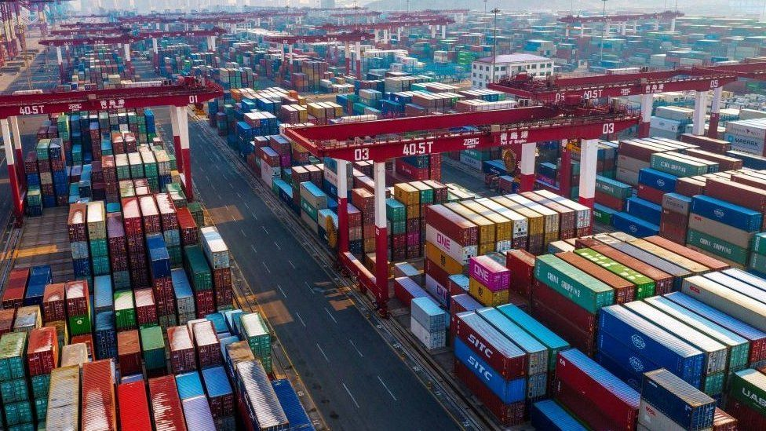IMAGE COPYRIGHTGETTY IMAGES
China plans to halve tariffs on 1,717 goods it imports from the US as the country faces the fresh challenge of the coronavirus.

Chinese officials said tariffs on some goods would be cut to 5% from 10%, and on others from 5% to 2.5%.

The two countries have been stuck in a long-running trade war with both imposing tariffs on imported products.

A partial resolution was agreed last month with China promising to boost imported US goods by $200bn.

This latest announcement to reduce tariffs is China's first response to the "phase one" agreement .

China's economy has been under additional pressure this year as the coronavirus outbreak threatens to derail the economy. Factories across the country remain closed and its manufacturing sector faces a severe drop in production.

The tariff cuts, which cover $75bn of US goods coming into China, will take effect on 14 February. Tariffs remain on a further $35bn worth of US goods.

The US will also roll back some tariffs on Chinese goods as part of the agreement.

It is being seen as a significant step towards resolving the US-China trade war. In a statement, China's finance ministry said the aim was ''to promote the healthy and stable development of Sino-U.S. economic and trade relations''.

Talking about the timing of the tariff reductions, Julian Evans-Pritchard, senior China economist at Capital Economics, said: ''Perhaps they want to show goodwill and send the message that they are still committed to de-escalating trade tensions despite the coronavirus delaying the ramp-up in their imports from the US''.

Stock markets around Asia rallied on the news. Both Hong Kong's Hang Seng and Japan's Nikkei 225 both rose 2.6% following the announcement.

Source :-

"China Halves Tariffs On More Than 1,700 US Goods". BBC News, 2020, https://www.bbc.com/news/business-51353503. Accessed 27 Nov 2020.

URL :- https://www.bbc.com/

International Economics Commentary: -

This article talks about the elimination of 50% tariffs (a trade restriction where taxes are charged on price of imported goods) on 1717 US goods in China. Acknowledging the threats of ongoing pandemic shutting-down the Chinese economy and tariff’s detrimental effects on exports, China believes that plummeting tariffs by 50% could ameliorate the country’s Gross Domestic Product(GDP), i.e. summation of monetary value of all the products produced in economy.
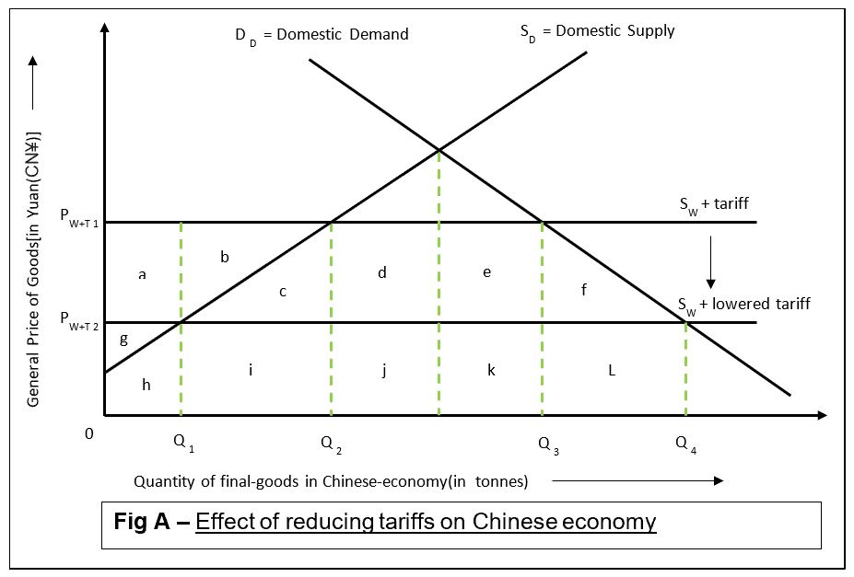
Fig.-A portrays the quantity of goods demanded and supplied in China, before and after tariff reduction. Here, the equilibrium is determined by intersection of domestic demand with foreign supply, which is at quantity Q₃ out of which Q₂ is supplied by Chinese domestic producers while the remaining(Q₃- Q₂)is produced by foreign producers. This reduction in tariffs “from 5% to 2.5%” and “5% from 10%” ensures a reduction in costs of foreign goods which incentivizes an increase in its supply, as is evident from the downward shift of S_{w+tariff} curve commensurate by the amount of tariffs reduced, which increases total quantity consumed (Q_{3→} Q₄) and quantity supplied by foreigners (Q₁→Q₄). Consequently, domestic supply of goods is decreased (Q₂→Q₁). Additionally, revenue of domestic supplier, i.e. total area below the respective supply and demand curve, gets reduced from (g+a+b+c+h+i) to (g+h). Along this, foreign supplier revenue increases too [from (j+k) to (i+j+k+l)]. The decision of cutting tariffs by half directly implies decrease in money flowing to the Chinese government and therefore, reducing its government revenue i.e. equivalent to 50% of the previous tariff amount.
The reduced tariffs will certainly prove beneficial to consumers as their overall spending will reduce in purchasing high quality goods. However, domestic producers will be worse-off as local quantity of goods supplied is reduced(Q₂→Q₁). Nevertheless, the domestic producers aren’t completely deserted because the lowered tariffs still ensures that foreign suppliers will not exploit the Chinese market entirely. Furthermore, the reduced tariffs can prove advantageous to Chinese exporter as well. It has been often observed that protectionist measured affects economies similar to a chain; seeing china reduce tariffs on US goods, it is extremely probable that US will follow the same by decreasing tariffs on Chinese goods which would incentivize the demand of Chinese goods in US market, thus increasing profitability of Chinese exporters, as a result, increasing Gross National Income(GNI) [GDP + net income flow), because of substantial increase in cash inflow from the US.
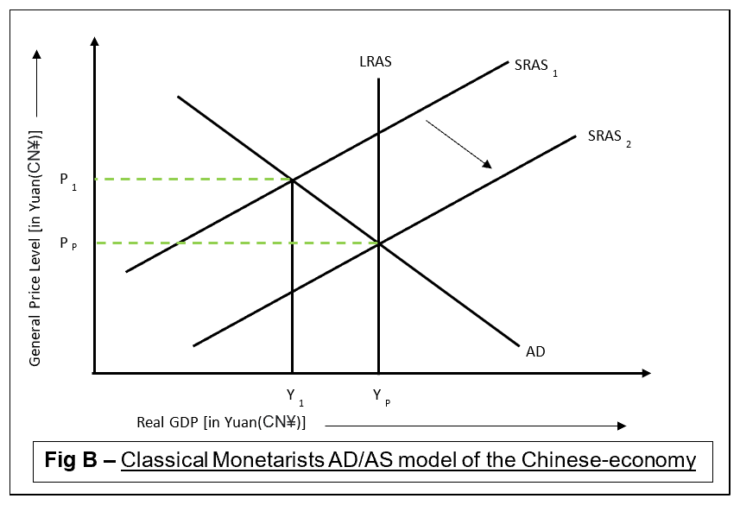
Fig.-B emphasizes the state of Chinese economy. Here, the considerable reduction in percentage of tariffs imposed on US goods by China is due to the threat from ongoing pandemic along with current trade war within China and US, that has left factories empty, decreasing their production which is reflected in Fig.-B with a shift in SRAS curve (SRAS₁→SRAS₂). Here, the real level of output is demarcated by intersecting point of AD with SRAS curve which portrays less than optimum level of output as Y₁ (current equilibrium quantity of real GDP) is relatively lesser than Y_{P} (potential maximum employment level). This reduction in production signals to the increasing no. of workers who are getting redundant; unemployment rate is more as compared to the minimal feasible rate. Also, acknowledging the fact that China majorly imports raw materials to manufacture it, this reduction in price of foreign goods would decrease production costs for local Chinese producers, hence, signalling them to increase production due to considerable rise in profit margin. And because reduced costs is a non-price determinant of supply it would lead to a favourable rightward shift (SRAS₁→SRAS₂), that’ll make the new equilibrium coincide with Y_{P} (level of full employment).
Whilst, Chinese government will experience reduction from tariff revenue, a part of this reduction will be offset by remittances from Chinese exporters and regardless, reduced revenue is a small expense to pay for gains of reduced protectionism. Additionally, Chinese consumers will now experience enhanced freedom among consumption choices, even though few domestic producers will be worse off, they’ll still exploit their relative advantage because of 50% tariff.
Additionally, China will benefit on an macroeconomic level since suppliers of key-industries will experience reduced production costs. The major purpose of reducing tariffs is its competency in stimulating local production within the pandemic. Therefore, the implications of reducing tariffs in the long-term are increased profits for Chines exporters, enhanced local production and reduced unemployment. All this would increase the yield of cash inflows within Chinese economy. As a result, recovering the detrimental economic situation of China; reduced protectionism would improve trade relations within China and US in future.

Word Count = 747

